An Implementation and Analysis of Core Text Representation Models

Juan Carlos Miguel V. TImoteo
Computer Studies and Engineering
Jose Rizal University
Mandaluyong, Philippines
juancarlosmiguel.timoteo@my.jru.edu

Abstract—This paper presents a detailed, hands-on analysis of core techniques for text representation in Natural Language Processing (NLP). The central aim is to explore and contrast the operational mechanics of four foundational methods used to transform unstructured text into structured numerical vectors for machine learning applications.The techniques to be considered are - Dictionary Lookup, One-Hot Encoding, Bag-of-Words (BoW) and Term Frequency-Inverse Document Frequency (TF-IDF). The comparison shows the inherent trade-offs between the models, the simple encoding schemes where only the basic mapping of tokens is possible and plenty of information is lost to the frequency-based models with BoW and the more advanced term-weighting in the BoW-based TF-IDF model. Important findings are a re-affirmation that text normalization is a necessary step, computational obstacles lying behind the data sparsity problem and large dimensionality, and the importance of ensuring that the representation model used resolves to the particular aims of an NLP task. Such research provides a clarifying manual to the concepts of text vectorization.
Keywords—Natural Language Processing, Text Representation, Feature Extraction, Dictionary Lookup, One-Hot Encoding, Bag-of-Words, TF-IDF, Vectorization

Introduction
In this current digital context, unprecedented amounts of data are created in the form of unstructured text, in the form of social media interactions and emails to academic research and news articles to name but a few. It is the increase in this textual information that has contributed towards a surge in growth in Natural Language Processing (NLP) an area of artificial intelligence that is concerned with allowing computer programs to comprehend human language as well as interpret and produce it [13][15]. One of the major issues encountered in NLP is the gap between the human and machine.
The primary objective of this paper is to conduct a practical examination of fundamental text representation techniques. This study documents and analyzes the application and behavior of four seminal methods: [1] Dictionary Lookup, [2] One-Hot Encoding, [3] Bag-of-Words (BoW), and [4] Term Frequency-Inverse Document Frequency (TF-IDF) . Each method offers a distinct balance between computational simplicity, memory usage, and the preservation of linguistic information [14]. The investigation was performed by annotating a Jupyter Notebook that implemented these techniques using Python. The analysis focused on key tools like the CountVectorizer and TfidfVectorizer from the scikit-learn library, documenting the function, syntax, and outputs of each code segment to build a clear understanding of text vectorization mechanics. This function automates the calculation of two key statistics, as illustrated by the formula in Fig. 12: Term Frequency (TF): The frequency of each word in a document, identical to BoW. Inverse Document Frequency (IDF): A weight assigned to each word, where common words (e.g., "is," "the") receive a low score and rare words receive a high score.This paper is structured to summarize the findings, detailing the advantages and disadvantages of each method before concluding with key lessons learned regarding the real-world application of these foundational NLP concepts.

Methodology
This section provides a detailed analysis of the observations recorded during the hands-on implementation of each text representation technique within the Jupyter Notebook environment.

Dictionary Lookup

The most elementary approach to text vectorization investigated was Dictionary Lookup. This method establishes a direct mapping between each unique word in a text corpus and a distinct integer identifier. The process was carried out in two main phases. First, a vocabulary was built by tokenizing each sentence into individual words and using a Python set to collect only the unique terms, as shown in the tokenization process in Fig. 1. The use of a set was a crucial detail, as it efficiently handles the automatic removal of duplicates.

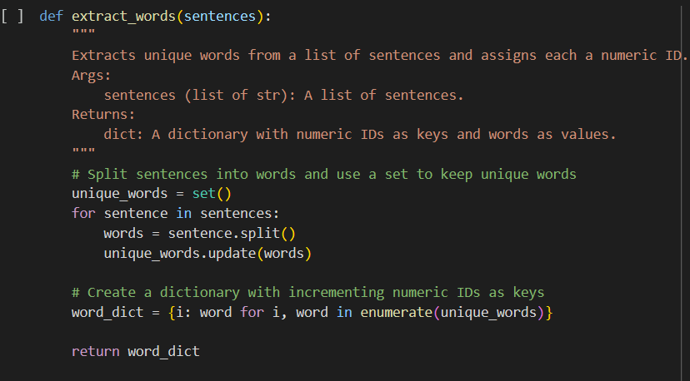
- Tokenization

Following vocabulary creation, the enumerate function was employed to assign a sequential integer ID to every word, creating a word_dict that serves as the lookup table (Fig. 2).

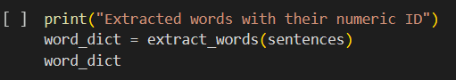
- Word_dict numeric id
A key finding from this process was the case sensitivity of the resulting dictionary. For instance, "The" and "the" were treated as separate tokens and assigned different IDs. This demonstrates the necessity of text normalization—such as converting all text to lowercase—a standard preprocessing step that was intentionally omitted here to highlight its impact [2][7]. An interactive loop, as depicted in Fig. 3, confirmed the functionality of the lookup dictionary by allowing word retrieval based on its assigned numeric ID.
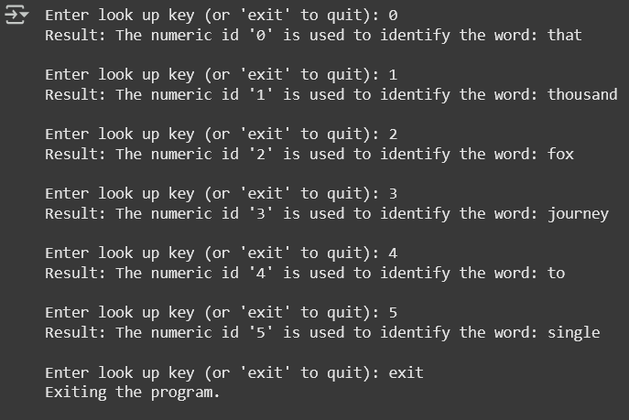
- Lookup Dictionary loop

One-Hot Encoding
The second technique, One-Hot Encoding, advances beyond simple dictionary lookup by representing each word as a unique binary vector. [3]. In this model, each word occupies its own dimension in a high-dimensional space (4). The implementation was performed manually using Python and NumPy, involving three primary steps. First, a token_index dictionary was created by iterating through the sentences and assigning a unique integer ID to each distinct token (Fig. 4).
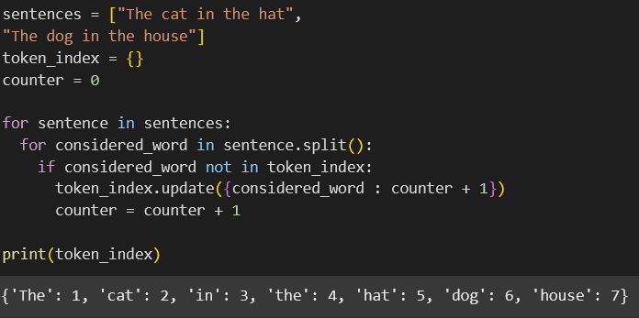
- Indexing The vocabulary
Next, a 3D NumPy array was initialized with zeros (Fig. 5). Its dimensions—(number_of_sentences, max_sentence_length, vocabulary_size)—were designed to hold the vector representations for every word in the corpus.
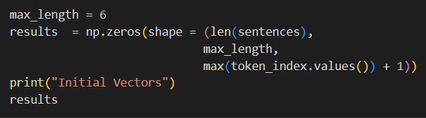
- Matrix intialization for word represntation
Finally, the code iterated through each sentence, and for each word, it used the word's ID from the token_index to "activate" a single bit in the corresponding vector by changing its value from 0 to 1 (Fig. 6).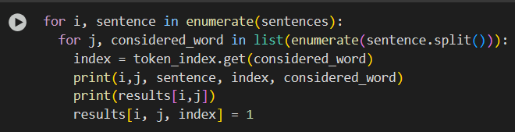
- Sentence Iteration to populate the vector
Vector Population: Next, each word in every sentence was iterated through by the code. It obtained the distinct ID for every word from the token_index. The value at that location was then changed from 0 to 1 by using this ID as an index to "turn on" a single bit in the matching word vector.
- Results and Key Observations:
The final output was a 3D tensor where each sentence was represented by a matrix of one-hot vectors.
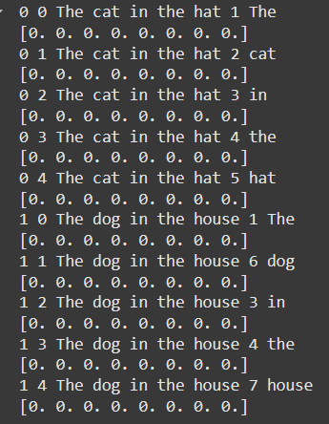
- Binary conversion for every word
Vector Representation: All Word is successfully transformed into a binary vector that contains zeros in other places and a single "1." For instance, the vector [0, 1, 0, 0, 0, 0, 0, 0] was used to represent the word "The" (ID 1). This gives every token a clear number representation.

Sparsity: The resultant vectors are naturally sparse, this means that nearly all of them are zeros. Each vector of length 8 in our tiny sample include a single non-zero member. Larger vocabularies cause this sparsity to become much more noticeable, which can result in substantial computational and memory overhead.[4]
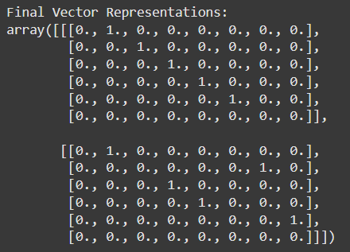
- Matrix maximum length
Padding: Padding was produced by using a fixed max_length for phrases. The last rows of each sentence's matrix were left as all-zero vectors because our phrases were shorter than the maximum length of six. This method is frequently used to guarantee that every data point has a consistent shape, which is necessary for machine learning models

Bag-of-Words (BoW)
- Implementation and Process:
The Bag-of-Words (BoW) model, which depicts documents according to word frequency, was the next step in the investigation. This method quantifies a word's occurrences rather than merely noting its presence[3][5[6]. This was accomplished using the highly optimized CountVectorizer class from the scikit-learn library, as opposed to the manual method used in the preceding section.
The execution was quite effective. Fit_transform, a single algorithm, was applied to the sentence corpus. This technique completed two tasks at once, streamlining the entire process:
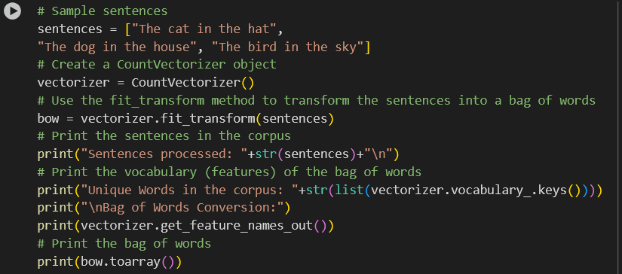
- Fitting and transformation

Fitting: It learned the lexicon of every unique word by scanning the complete corpus.
Transforming: Every phrase was transformed into a numerical vector, with the raw count of the relevant word from the lexicon represented by the value at each location.
- Results and Key Observations:
The result was a 2D matrix with a unique word from the learnt vocabulary displayed in each column and a sentence in each row. Several significant findings emerged from the outcome:
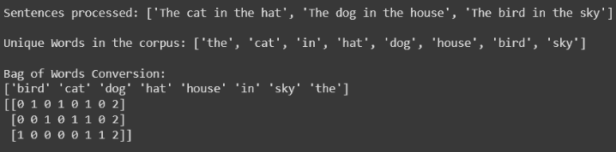
- Conversion of words to lowercase

Term Frequency-Inverse Document Frequency (TF-IDF)

The final and most statistically nuanced method analyzed was Term Frequency-Inverse Document Frequency (TF-IDF). This technique refines the BoW model by weighting words based not just on their frequency within a document but also on their uniqueness across the entire corpus (18, 30). The implementation was handled efficiently with scikit-learn's TfidfVectorizer. Similar to CountVectorizer, the process was executed with a single fit_transform call (Fig. 11). The analysis was carried out within the context of a Jupyter Notebook, which was annotated to read in Python these techniques. Some of the important tools to look at were CountVectorizer and TfidfVectorizer in the scikit-learn library with the functions, syntax and the outputs of each of the segments analyzed to create a concise picture of the mechanics of text vectorization.
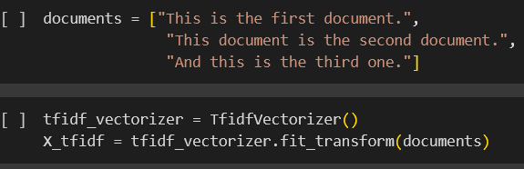
- Using of fit_transform for TF-IDF

- Formula of TF-IDF

The method multiplies these two scores to generate the final TF-IDF value for each word. The output was a 2D matrix of floating-point TF-IDF scores (Fig. 13).

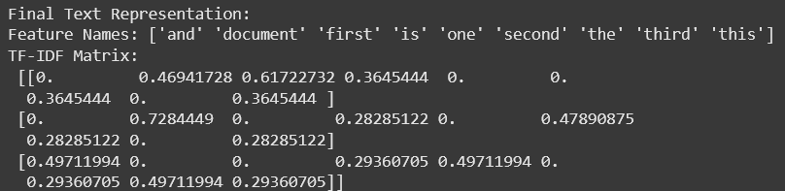
- Result of TF-IDF
The results effectively highlighted the most characteristic words in each document. For instance, in "This is the first document.", the word "first" received the highest score because it was unique to that document and thus deemed more informative. Conversely, common words like "this" and "is" received lower TF-IDF scores despite their high frequency, demonstrating TF-IDF's strength in filtering out stop words without requiring an explicit list [5]. The vectors produced by TfidfVectorizer are also typically normalized, ensuring that document length does not skew the importance scores.

Comparative Analysis and Discussion

The hands-on analysis of these four text representation techniques yielded several critical insights into the foundational principles of NLP. The progression from simple to complex methods illuminated the trade-offs between simplicity, information fidelity, and computational expense.
A foremost lesson was the paramount importance of text normalization. The manual implementations of Dictionary Lookup and One-Hot Encoding were case-sensitive, which inflated the vocabulary. In contrast, scikit-learn's vectorizers performed automatic lowercasing, showcasing how robust preprocessing is an essential step for consistency and efficiency in any serious NLP pipeline [2].
Furthermore, the exercise provided a tangible understanding of the Curse of Dimensionality and data sparsity. One-Hot Encoding, while providing a distinct vector for each word, generates extremely high-dimensional and sparse representations that are computationally intensive and impractical for large-scale applications.
The point that has most impressed me, though, is the common disadvantage of all four models of the bag-of-words approach; the utter lack of consideration given to word order, structure, and semantics [5][9][12]. Such models cannot make the distinction between dog bites and man bites and vice versa. In the same line, one loses all semantic relationships, the realization that a cat and a dog are more connected to each other in comparison with house (1). This is because it is an inherent limitation that makes such approaches only appropriate to general tasks such as general document classification but not to discrete topics such as machine translation or question answering, which require a richer grasp of language (5). Such shortcomings explain the reason why even more sophisticated methods such as word embeddings (e.g., Word2Vec, GloVe) are needed and meant to capture rich semantic connections between words in context [10].

CONCLUSION
This introduced the basics of text representation techniques in Natural Language Processing in an extensive and working fashion. This paper has managed to demystify the inner workings of Dictionary Lookup, One-Hot Encoding, Bag-of-Words, and TF-IDF because it follows the step-by-step procedure of their implementation and exposes their advantageous specifics and the most significant shortcomings..

The inquiry re-established the truth that transforming textual material into a numeric data form has become an indispensable requirement of the machine learning programs. The transformation of the straight integer mapping of Dictionary Lookup to the tf-idf scores weighted according to their significance and used in a variety of statistical methods demonstrates a definite step to the development of more informative and effective representations of vectors. The productivity of tools in the scikit-learn library was of special interest because they can be applied in automating challenging preprocessing and other statistical computations enabling the use of advanced models such as BoW and TF-IDF to practitioners [5].

All in all, this research reminds that there is no single best way to represent text. This depends on the demands of the actual NLP task to be addressed and needs to maintain a delicate trade-off between the requirements of linguistic depth and computer resources at hand. This is a basic grasp any practitioner cannot miss to establish effective and efficient NLP models.

References
- Al-Azzawy, D., & Al-Zamily, H. J. (2020). A Survey on Bag of Words, TF-IDF, and Word-Embedding as Text-Representation Methods. Journal of Al-Qadisiyah for Computer Science and Mathematics, 12(2), 52–61.
- Jian, Q., & Wang, Y. (2018). The Role of Text Normalization in Natural Language Processing. Proceedings of the 2018 International Conference on Big Data and Artificial Intelligence, 1-5.
- Rodriguez, P., & Ramos, J. (2019). An Analysis of One-Hot Encoding for Text Classification. Journal of Data Science and Engineering, 4(3), 213–225.
- Hughes, G. (1968). On the mean accuracy of statistical pattern recognizers. IEEE Transactions on Information Theory, 14(1), 55-63.
- Zhang, Y., Jin, R., & Zhou, Z. H. (2010). Understanding bag-of-words model: a statistical framework. International Journal of Machine Learning and Cybernetics, 1(1-4), 43-52.
- Blei, D. M., Ng, A. Y., & Jordan, M. I. (2003). Latent dirichlet allocation. Journal of machine Learning research, 3(Jan), 993-1022.
- Jurafsky, D., & Martin, J. H. (2023). Speech and language processing (3rd ed. draft). https://web.stanford.edu/~jurafsky/slp3/ (37, 45)
- Turney, P. D., & Pantel, P. (2010). From frequency to meaning: Vector space models of semantics. Journal of artificial intelligence research, 37, 141-188.
- Manning, C. D., & Schütze, H. (1999). Foundations of statistical natural language processing. MIT press. (13, 24, 32, 47)
- (Mikolov, T., Chen, K., Corrado, G., & Dean, J. (2013). Efficient estimation of word representations in vector space. arXiv preprint arXiv:1301.3781.
- (Le, Q., & Mikolov, T. (2014, June). Distributed representations of sentences and documents. In International conference on machine learning (pp. 1188-1196). PMLR.
- (Pennington, J., Socher, R., & Manning, C. D. (2014). Glove: Global vectors for word representation. In Proceedings of the 2014 conference on empirical methods in natural language processing (EMNLP) (pp. 1532-1543).
- (Salton, G., Wong, A., & Yang, C. S. (1975). A vector space model for automatic indexing. Communications of the ACM, 18(11), 613-620. (18, 30, 39, 46)
- Jones, K. S. (1972). A statistical interpretation of term specificity and its application in retrieval. Journal of documentation, 28(1), 11-21.
- (Peters, M. E., Neumann, M., Iyyer, M., Gardner, M., Clark, C., Lee, K., & Zettlemoyer, L. (2018). Deep contextualized word representations. arXiv preprint arXiv:1802.05365.

